***Software Requirements Specification***

**Online Banking System**

**黃啟瑞 B073040046**

**劉洮語 B073040028**

**彭煜博 B073040002**

Table of contents

1. Introduction

1.1 Purpose

1.2 Scope

1.3 Terms and abbreviation

2. Overall description

2.1 Product perspective (level 0 & 1)

2.2 Product functions (DFD level 2)

2.3 Requirements

2.4 Constraints and extended

3. Specific requirements

3.1 Graphical User Interface (GUI)

3.2 Cost for design

4. Summary

Introduction

This section gives a scope description and overview of everything included in this SRS document. Also, the purpose for this document is described and a list of abbreviations and definitions is provided.

Purpose

The purpose of this document is to give a detailed description of the requirements for the “Online Banking System” (OBS) software. It will illustrate the purpose and complete declaration for the development of system. It will also explain system constraints and interactions with other external applications.

Scope

The “Online Banking System” is a financial security-based PC application which makes people to share the services from the bank without walking out home. The software needs both Internet and valid bank account to normally functioned. All personal information and upload documents during operation are only for verification and recognition, which is absolutely save and were not leak outside. However, the application could not be download now, due to it is not exist.

Terms and abbreviation

|  |  |
| --- | --- |
| OBS | Online banking system |
| FO | Financial operation |
| AM | Account management |
| Invoice device | Use phone to store invoice (means business log) |
| Stock exchange | A place to invest (means all investments) |
| Voice channel | A platform provides help by instant voice |
| Sub-system | Independent from OBS, which is small and easy |
| Credit center | An institution records a person’s credit |
| Bank No. | A number represents different bank |
| PMs | Person months |

Overall description

This section will give an overview of the whole system. The system will be explained in its context to show how the system interacts with other systems and introduce the basic functionality of it. At last, the constraints and assumptions for the system will be presented.

Product perspective

This system is an ATM like system. We add most of existing functions into our system and a few special functions. First, users have to login the system with bank account and password. And then, the system will connect to the bank background database to access the user’s account control right. Second, users choose the function they need and follow the next stage indications.

We divide all functions into three parts, that is Financial Operation, Account Management, and Other.

Product functions

What would users want:

1. Move money from account to account 🡪 Money transference
2. Borrow money from bank 🡪 Loan
3. Apply credit card 🡪 Credit card application
4. Check account owner/remainder 🡪 View account information
5. Trace money-flow 🡪 Check transaction log (sub-function in view account)
6. Change account password/security password/link with e-mail address 🡪 Security
7. Stock market 🡪 Investment
8. Pay national bill at home 🡪 Bill payment
9. Convenience 🡪 Support mobile payment

Analysis:

* Money transference, loan, bill payment, investment 🡪 Financial operation
* View account information, security 🡪 Account management
* Credit card application 🡪 Online application system
* Support mobile payment 🡪 sub-system link with external mobile pay devices
* Online customer service 🡪 other help

(handle the problems from users about the system)

Requirements

Implement the functions includes

1. Financial operation

Money transference

Loan

Bill payment

Investment

1. Account management

View account information

Security

1. 一張含有 文字, 地圖, 桌, 白色 的圖片

   自動產生的描述Online application system
2. 一張含有 文字, 白色, 桌, 黑色 的圖片

   自動產生的描述Support mobile payment
3. 一張含有 室內, 白色, 相片, 公開 的圖片

   自動產生的描述Online customer service

Use case diagram

Sequential case diagram

Constraints and extended

There is a lethal problem that we cannot instantly deposit or withdraw money from OBS. Thus, the field of physical money usage is not we should focus on. Instead, we support mobile payment device. We make attempt to link bank account to a mobile payment application, which indirectly make account money a use.

Specific requirements

This section contains all functional and quality requirements of the system. It gives a detailed description of the system and all its features.

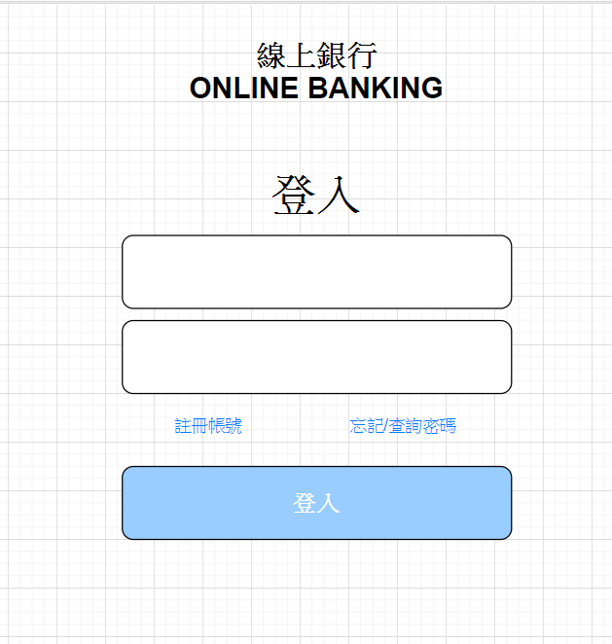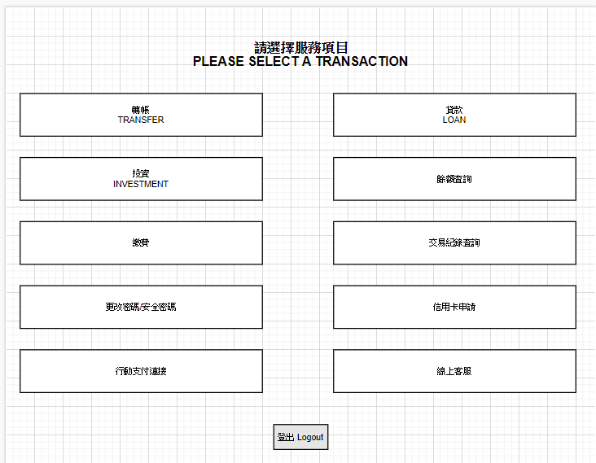Graphical User Interface

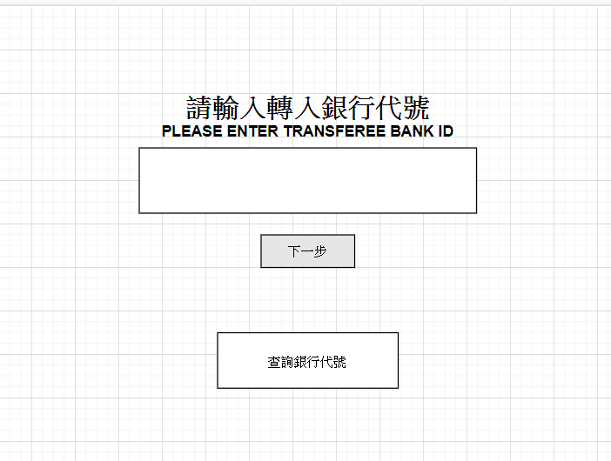Money transference

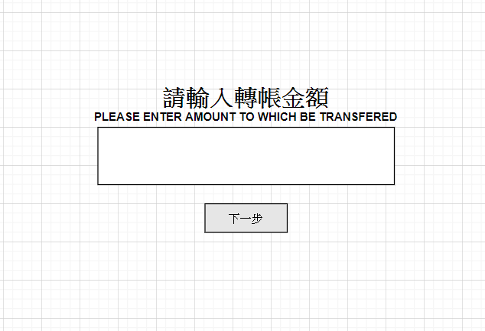

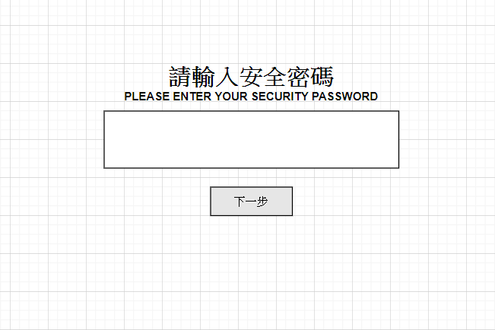

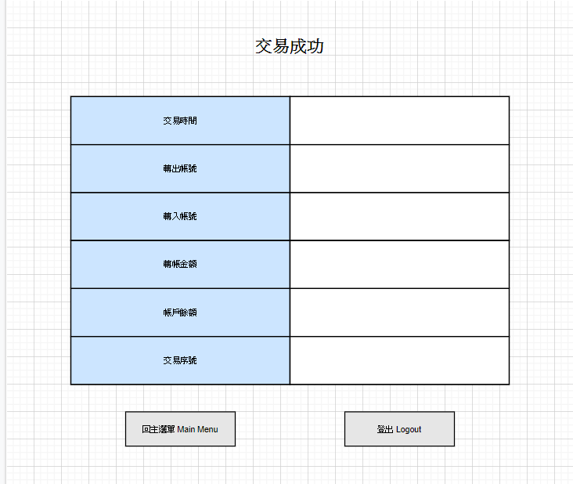

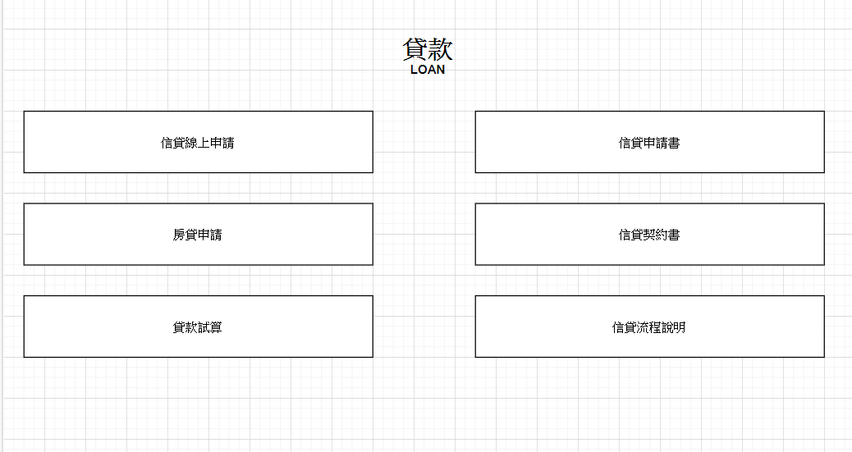Loan

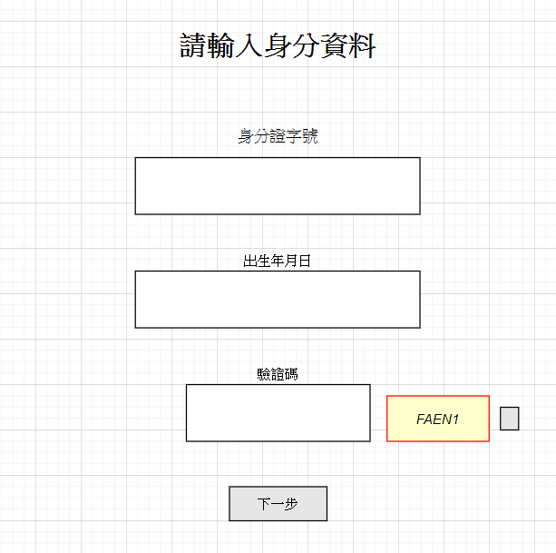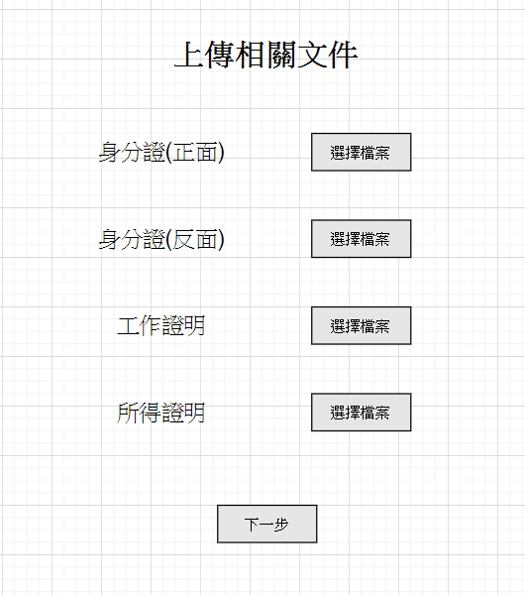

Credit card application

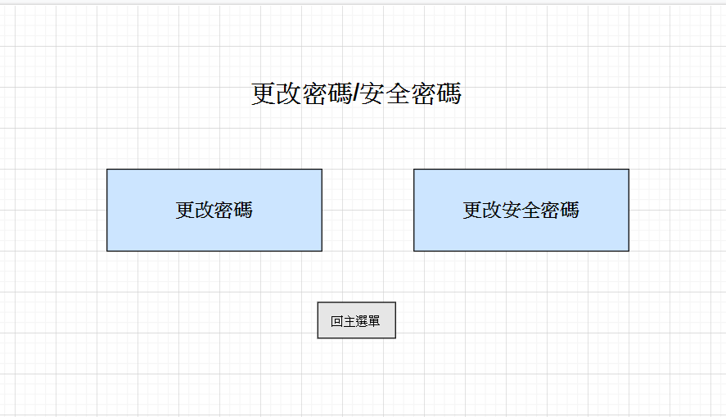Security

Investment

Mobile payment link

Bill payment system

View account information

Online customer service

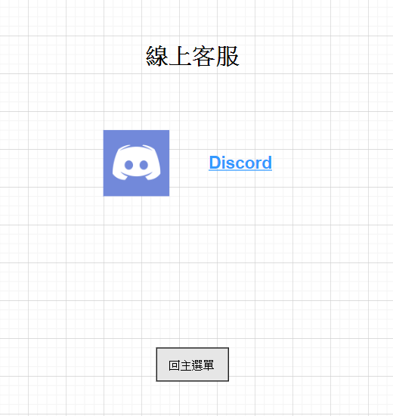

Cost for design

We use COCOMO model to estimate some figure about OBS.

OBS is an organic project type.

Suppose the size of our project is 150 thousand lines of code. Thus, we get KLOC = 15

Effort = 2.4(KLOC)1.05

E = 2.4 * (400)1.05 = 2.4 * 192.70 = 462.5(PMs)

Development time = 2.5(Effort)0.38

D = 2.5 * (462.5)0.38 = 2.5 * 10.30 = 25.7(Months)

Summary

Finally, we finished construct the whole thoughts of OBS. We build functions which meets users’ requirements, also add some new function in it. We adopt direct way and simple UI to speed up the process of banking. Compare to physical bank, this system greatly shortens the time on waiting in line. Thus, we can say our project is match to the customers’ expectation.